# About Uber

by Peter Cohen, Robert Hahn, Jonathan Han, Steven Levitt, Robert Metcalfe

|  |  |  |  |  |
| --- | --- | --- | --- | --- |
| Image result for UBER |  | |  | | --- | | THE FUTURE OF UBER | | Image result for FAKE CONSULTING COMPANY LOGO | |
|  |  |  |
| uber |  | In This Issue |

Uber is a technology company founded in 2009, which created a smart phone application that matches and handles payments between consumers seeking rides and Uber’s “driver-partners.” Uber’s service has proven extremely popular, growing dramatically in terms of both geography and volume

UberX is an app-based service that algorithmically matches drivers to consumers seeking rides.

To use Uber, a consumer downloads the app onto her smartphone for free. When seeking a ride, the consumer opens the Uber app and sees something akin to the screenshot in Figure 1. There is a map of the local area, a display of driver-partners in the area available to provide rides, and an estimate of how many minutes it will take the nearest vehicle to reach the consumer’s location. Uber offers a number of different products, as shown near the bottom of the screen in Figure 1. The user is able to scroll between those products. If a consumer places an order, driver-partners are sequentially given the opportunity to accept that order until one does so. That driver-partner then picks up the rider and drops her off at her desired location. Uber defines a user product session in which the user opens the app, culminating either in the user ordering a ride or electing

not to order a ride.14 Throughout this interaction, Uber records all actions taken on the app as well as certain background information relevant to the transaction. These data are collected and stored regardless of whether or not the session ends with a purchase.

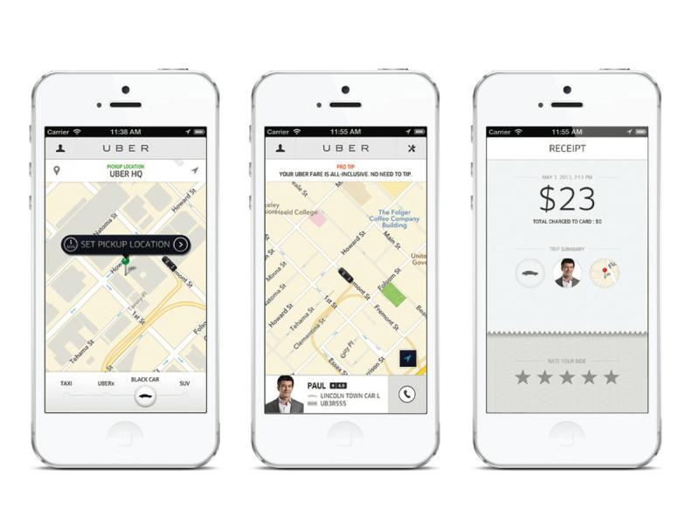

**Fig. 1: Uber mobile application request screens**

Uber offers several products, which differ in terms of the types and size of cars, whether the ride

is shared with other passengers, and the price. Our focus is on UberX, the core product that represented almost 80 percent of all Uber rides during the time- period of our sample. With UberX, a rider summons a driver-partner who drives her own private vehicle and delivers the rider to the desired location without stops.

### The impact of Uber on taxis

by Your names here

To complete this section of the report please answer the following questions:

**As you know taxi drivers are licensed to be able to operate. How does licensing affect the supply of taxi drivers? How does it affect the price of taxis?** With an increased barrier to entry, the supply of taxi drivers is not only affected by direct competition with other ride hailing services, but also by defectors of the taxi industry. In this situation, the more appealing option for a professional, at least as a short-term solution would be to drive for Uber. Logically, if the supply of taxi drivers were to decline, the taxi industry would need to raise prices on rides to subsidize the cost of the rides that they are now missing out on with a lessened workforce. The transportation industry is elastic, meaning for a unit change in price, there will be an impact in demand. If taxi companies were to raise their prices to account for the shortage of drivers, they would be met with a decline in demand on the user/customer side. It should be noted, however, that some states are starting to require licenses beyond CDLs for Uber drivers. In New York, Uber drivers are required to acquire a “Limousine Commission License”. [1]

**How do you see the future of the taxi industry given the entrance of Uber/Lyft etc. Explain this using the notion of creative destruction.**

I personally believe the Taxi industry to be a dying breed. As noted above, they are trapped in a perpetual cycle that is proving difficult to claw out of, especially since Uber is taking some small steps towards mitigating recent legal issues [3]. If it is considered, legally, that Uber is not willfully bypassing the terms of transportation laws in which the company operates, it would be a tall task to regain market share and sway conquestors of the industry back into full-fledged brand loyalists.

Creative Destruction is a common theme of the current information era. The old is forced out in favor of the new, and the better, often for hope of moving the needle forward on our own technological abilities, as humans [3]. It isn’t always the case that innovation is guaranteed to push the limits of competition in a free market, nor that such innovation is free of impractical solutions to pseudo-problems. In the case of Uber and the ever-present reality of the transportation industry, a resolution was reached among consumers due to flaws in the Taxi industry’s operation. From personal experience, having lived in Arizona for most of my life where taxi supply is scarce, it was simply too difficult and costly to think about taxis as a viable option. It probably correlates with our high count of DUIs in the first part of the 21st century [5]. Uber presented a cleaner, more elegant solution that solved these problems.

**What made Uber so successful? (explain this using the notion of standards, tipping points, switching costs and lock in effects and transaction costs)**

If we look at Uber’s standards at an elevated level, from a driver to drivee relationships (ignoring some of the missteps of Travis Kalanick) we can see that vehicles within the fleet must be no greater than 10 years of age, they are always available, and the position themselves as a countermeasure from driving under the influence [4]. Anecdotally, I’ve always found cabs to be claustrophobic and unwelcoming, but driving in a normal car with a friendly person (most of the time) is pleasing. Tipping points are known as occurrences of minor changes that dismantle the status quo [6]. In the case of Uber, some of those tipping points were: simplicity of the ordering process, having the ability to know when your car would arrive, ease of payment due to credit card linkage, price transparency, and universality [7]. You also didn’t have to worry about tipping in past years, but that structure has changed to allow customers the ability to reward drivers based on their respective experience.

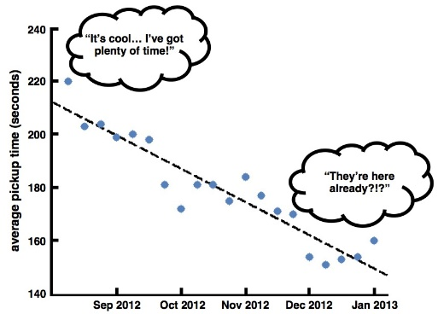

Average pickup time for Uber, in seconds. [8]

Switching costs aren’t prominent in the ride hailing industry yet. A consumer can, and often does, switch between Lyft and Uber without hassle[11]. In it’s prime, Uber had the lock in effects of having an incredibly large network of drivers that was assured to reduce wait time over all competitors. As Lyft has grown, it’s becoming much more difficult to force brand retention. In the traditional sense of a transaction cost, Uber alleviated much of the pain, and the time-consuming burden that incurred through booking a taxi, or alternate mode of transportation. By easing user burden, especially at great price, it was easy to understand why word of mouth helped Uber to expand and grow to what it is today.

**Is the presence of Uber making the market more competitive today?**

Yes, the emergence of a new sector of the transportation industry, while initially dominated by Uber, has forced older models to adapt, and has ushered in a new era of ride hailing. Uber is known for being the first, but, due to some breaches in data and some less than ethical behavior from their former CEO, they have opened the door for others, namely Lyft. Competition could be explained by a resulting change organizational practice pertaining to employee and customer, as well as the strategic operationalization of the business plan. Unfortunately, the Taxi industry has been unable to compete in one of the most important regards, price. “Taxi fares tend to be regulated-so prices change slowly and an individual driver has little control over them” [9]. This leaves modernization of the existing landscape as a short-term solution to combat overwhelming competition.

|  |
| --- |
| Impact of Uber on Taxis Cont. |

**Will the market remain competitive five years from now? (explain this using the winner takes all markets)**

Yes, I do believe that the market will remain competitive in the near, and even in the distant future. I was initially hesitant, as the market does tend to migrate and establish loyalty, but was enlightened by a Medium article on the subject [10]. The author posits that there is an inherent deterrent present that makes a monopolistic resolution unrealistic in the current landscape – The constraint presented by gas and the cost of drivers. Any ride hailing company can squeeze innovation and modernization out to its precipice, but the ability to truly leverage network effects resides in the ability to create advantage that mitigates the other guy’s solution. Even if these companies subsidize the cost of rides in the short term to acquire customers, it isn’t a sustainable business model, and neither is reducing the cost of drivers, because you’d end up in a comparable situation to the taxi industry, where supply for drivers is low.

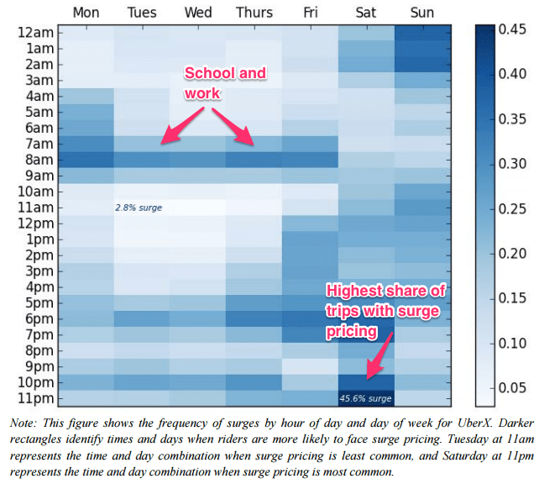

[13] Density heatmap of surging prices- Day of the week and Time of the day.

### Calculating the demand for Uber

by Jacob Dineen

What determines the demand for Uber?

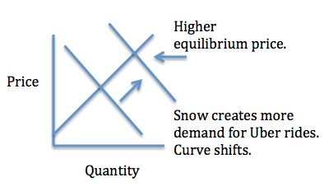

[13]

Demand for Uber can be attributed to many geospatial and temporal aspects, as well as pricing. Highly congested areas (NYC) where cars aren’t necessary may choose ride hailing as an alternate to owning a car. If we were to examine the impact of time/weather/locations on demand, we’d likely see common trends that point to diminished supply of drivers in the Uber fleet during a specific period. When there is a lesser supply of drivers, surge pricing kicks in, adding a unique reward for the driver who decides to take the ride.

**Prepare a graph with the demand curve for Uber services based on your own experience with the service and prices you have seen.**

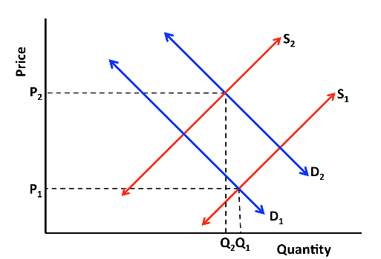

Based on my own firsthand experiences, I can’t say that the price has ever reached a point where my demand for the product was negated. Most of the time I use Uber when I’ve had a few too many drinks, and at that point, you just want to get home. At that point, even if pricing is surging, I certainly feel that the utility of the service is worth much more than what I am being charged – This rolls into consumer surplus below. There is certainly time when the surge is 2 or 3x that I will either switch apps, call a friend to pick me up, or just wait it out until demand in the area dies down and I can get a price at a normal rate.

**What are the mechanisms that Uber uses to generate additional demand for its services?** Uber has a relatively simple model create demand. It helps that they were first to market and had a vast network of drivers to market their business as the prototype for shorter wait time and lower prices. It is argued [14] that the likelihood of a consumer requesting the service sees a spike when wait times decrease, and as a result, more demand is created when pickup time is marginalized. By creating a supply of drivers, they are stimulating their own demand.

**Will Uber generate consumer surplus as they enter more cities?**

A screenshot of a cell phone

Description generated with high confidence

The above graph [12] shows the rate of purchases on various levels of surging from a sample of users. It attempts to express how many customers, within the sample, were willing to pay more for a good or service due to the value and utility that they measure the company with. The same article makes a claim, maybe over-generalizing, that the cost of Uber disappearing for a day would be $18mm in surplus to US consumers – This speaks to how much consumers value the product that Uber is offering.



### The costs for Uber

by Jacob Dineen

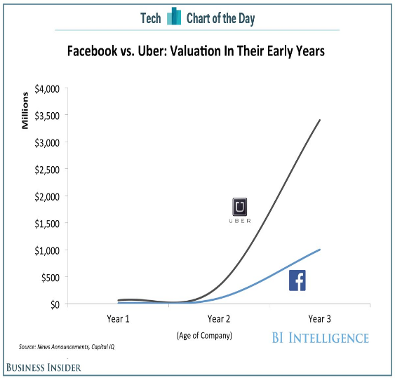

[16]

|  |
| --- |
| Fast Facts |

|  |  |  |  |
| --- | --- | --- | --- |
|  |  |  |  |

Uber considers their rise to be correlated and causal with the a decline in DUI arrest since its inception

|  |  |
| --- | --- |
|  |  |

Uber has pledged to take 1,000,000 cars off of the road in New York City [15]

**What are Uber fixed costs?**

Fixed costs are business costs that are independent of quantity demand or supply. Uber’s business model is new, and semi revolutionary, where the drivers are contractors, so their pay is not fixed, but is tied to the demand. Some of the fixed costs, in a traditional sense, are thing like application development (the portal with which the B2C relationship occurs), R&D (self-driving car initiative), salaries for non-contracting employees, marketing, depreciation, rent and utilities.

**What are Uber variable costs?**

A variable cost, unlike a fixed cost, is incurred through the fluctuation in activity. For the business of Uber, at a hierarchical level, their main variable cost is to the contracted employees within the fleet of drivers. The variable costs vary from city to city, but some statistics on collected data point to an average hourly driver rate of somewhere in the low $10-dollar range [17]. What is genius about the model, from a business standpoint, is that the driver is responsible for paying their own taxes, along with their own variable costs associated with gasoline, insurance, maintenance, and other miscellaneous expenses [18].

**How can Uber reduce its variable costs?**

Based on the above data, drivers are not exactly making a killing at an aggregate level, while this could, of course, vary from city to city where demand plays a role in dynamic pricing. If Uber were to reduce the amount that they paid drivers, or their cut of a particular ride, there would be penalties that follow. Namely, the network that Uber has worked hard to build up would begin to shrink with drivers switching in mass to other ride hailing services like lift. If that network were to dwindle, the wait time for rides would increase, thus propelling

a decrease in demand for the product. If the demand for the product were to diminish, the price of the product would need to be raised to cover that loss. With this industry, or sector of the industry, being elastic, a change in price will bring along a change in consumer demand for the product. With low switching costs and locked in effects, there isn’t really anything barriers that are preventing brand switching. The network externalities that allowed Uber to emerge and conquer the market would be flipped on their head if Uber were to drastically cut their variable costs. I personally see a change in tides coming along with the rise of recurrent and regionalized convnets for object detection and recognition. Once this tech proves its worth, the variable costs associated with paying drivers would be marginalized. The fixed costs would initially outweigh what is saved in variable costs, but in the long run, it would seem to be a viable solution. With the recent headlines concerning autonomous vehicles and claims that they are unfit for societal integration in their current form, we could be a long way off from this. It is interesting to ponder, nonetheless.

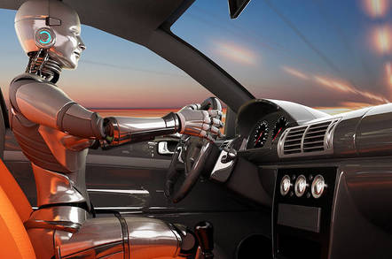

UBER IMPACT ON TAXI

To complete this section of the report please answer the following questions:

### Pricing for Uber services

by Jacob Dineen

**How does Uber make money?**

I think it is important to note that Uber does not currently operate in the black, and some sources point to Uber currently losing money on a per-ride basis to gain market share. Uber has two main sources of generating revenue. Those are through the transaction of charging customer for rides, and for promotion from various third parties integrated within the platform – Advertising, in fewer words.

**How do you think Uber determine its prices?**

From what I know about Ubers pricing structure is that it is dynamic, meaning that is influenced by demand. According to their own site, the variables impacting change in price are estimated time, traffic, and the supply and demand of the market at a given point in time.

**As you know Uber charges different prices for different types of rides. Why does the company do this? What is the company trying to achieve?**

Going away from the dynamic pricing structure that we mentioned previously, it is important to note that Uber caters to different segments of the population. Certain segments prefer adapted means of transportation, so the concept of market segmentation was introduced via different pricing tiers associated with different vehicles. The company does this because they understand that different customers have unique needs based on their demographic and behavioral characteristics. A large family needs the option to transport concurrently in the same vehicle, so they are given the option of paying slightly more to get an Uber XL, which is a fancy way of saying “you get an SUV instead of a sedan at a marked up price”. [20]

**If there were to be a “groupon” what is this “sale” attempt to do? (Explain these questions using the notion of price discrimination)**

I think that groupons in general are a way to reward brand loyalty, and to increase visible traffic and word of mouth for an organization. The sale is attempting to offer a reward to its user base, adding to the consumer surplus. Price discrimination occurs when the same product is sold from different amounts to different people. I think we see a lot of this when a person is just starting to use a product. They are given excessive breaks in pricing to gain their business and increase their customer lifetime value. You may get a free ride, or a certificate to use against a ride when first signing up for Uber. Alternatively, I think there may be systematic pricing discrimination within small towns, simply because of lack of supply on the driver side. Often, more price sensitive customers are targeted and provided with discounted goods while the latter cluster of individuals is shown the true price of the good. “The merchant gains as long as the lower price is higher than the marginal cost of producing their product or service [24].

**Is the demand for Uber services elastic or inelastic?**

As mentioned previously, the demand for Uber service is elastic. A change in price will result in a change in demand. Inelastic services would be deemed necessities, and potentially services or products that belong to a monopoly within a sector. A change in price, in that instance, would have a lessened or null impact on the change of demand. Ride hailing isn’t necessarily thought of as a necessity, because there are many alternatives in place.

**How do substitutes and complement affect the demand for Uber services?**

When I think about complementary goods in the case of the drivers within the fleet, I think of the price of gasoline. It seems to have a negatively cross elasticity with the demand of rides. I say this because, as noted earlier, there is a trickledown effect from the variable costs incurred by a driver and their willingness to supply their services to the company. Uber’s main substitute is Lyft. A price increase, to the user, in Uber’s product will decrease the quantity demanded for Uber and increase the quantity demanded for Lyft.

**Can you think of other services/products that could complement and benefit Uber?**

I think we must, again, look to the driver’s side to understand their variable costs and understand which things will have a negative cross elasticity with their supply and the impending demand. If maintenance, cost of living, depreciation and other costs were to decrease, there would be a positive effect on the supply of drivers.

To complete this section of the report please answer the following questions:

### Liability and insurance problem

by Jacob Dineen

**What is the purpose of insurance?**

Insurance is a means to mitigate risks for consumers and to protect them in the case of ‘catastrophic’ events.

**How does insurance work?**

Insurance works in its current medium by playing the odds of probability. If everyone is required to have insurance, there is a low probability that each person with insurance will be exposed to one of these catastrophic events. For insurance to work, there must be a large pool of people participating within the framework. Most of the time, the consumer pays a monthly fee for insurance, and the insurance agencies are banking on the fact that it is statistically unlikely for each consumer will file a claim within a given period. They are playing the lifetime value game, measuring the revenue generated by a person against the costs due to accidents or negligence.

**If Uber expands its use of autonomous cars who should be liable for an accident? (Explain this using the moral hazard problem and the principal agent issue)**

One of the issues of insurance in general is the notion of moral hazard. If a person is covered by insurance, there is a chance that people may be more reckless than if they were to not have insurance. If the large pool of people within the framework were to operate with moral hazard, it would prove the entire system to be ineffective due to large scale, negative events. In the case of autonomous vehicles, if an driverless, or driver assisted vehicle were to be involved in an action, Uber should still be liable for the resulting damage. “For fully autonomous vehicles, the blame can be assigned to, or shared by, one of many parties – including the manufacturer, the service centre and the vehicle owner” [21]. The principal-agent problem is when an agent, in this case a driver-less vehicle, can make actions on the principal’s, the passenger, behalf. It is interesting to see, with the accident(s) occurring lately with semi-autonomous vehicles, there hasn’t been a drastic change in public opinion on the validity and potential benefits of the medium. A further understanding of the P-A issue points to machines sometimes making decision that may incur negative penalties on the passenger. This ties back in with our discussion of machine ethics, and the advanced conundrum of the new-age trolley problem.

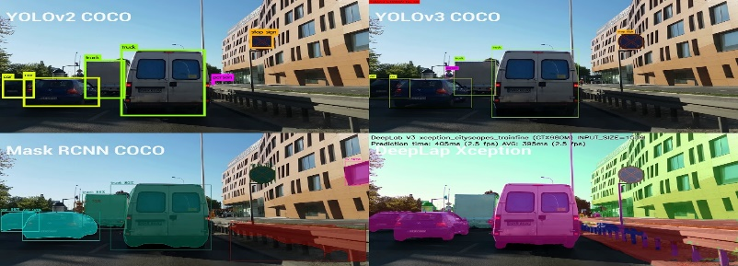

Yolov3 is a regionalized convnet used for object detection.

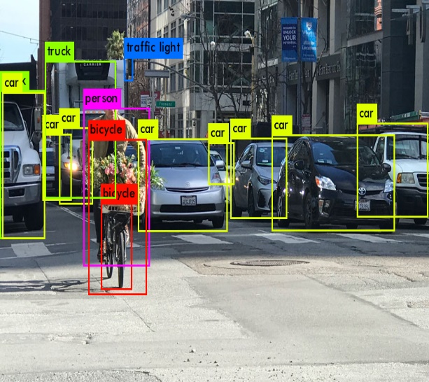

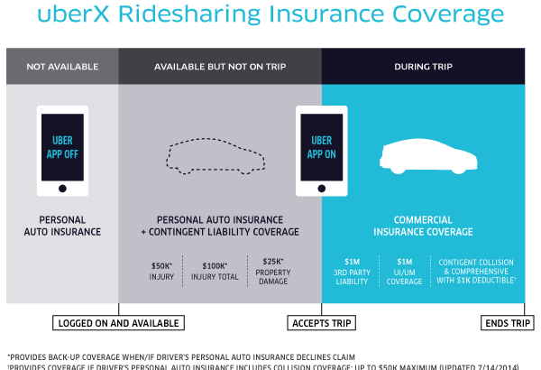

**Insurance Coverage provided by Uber.**

To complete this section of the report please answer the following questions:

**In a city with a much traffic how does it affect pollution levels? (explain this using the concept of externalities)**

Pollution is responsible for up to 30,000 premature deaths per year in North America, and the main sources of said pollution is passenger vehicles and heavy-duty trucks [22]. Externalities are side effects, or consequences, of changes in the status quo brought about by updates to industry. In this case we look at Uber. Worthwhile research has been conducted to see if the rise in ride hailing has reduced the overall impact on the environment. If we were to assume that everyone within the market was the same, all logical actors concerned about the environmental harm incurred using vehicles, we’d aim to reduce our own emissions. Said research indicates that one of the unintended externalities of Uber’s rise may be predicated in the notion that people are more willing to take public transportation to avoid traffic knowing that they have an alternative way of getting home.

**How is air pollution going to be affected with the presence of Uber?**

This is a matter of demand, and the success of pooling. If a single ride is substituting for many vehicles out on the road, emissions would be lower. In a way, one vehicle is replacing two if we consider the driver an actor as well, so reduction is happening at a base level. Contrary to that point, people may be more willing to travel/drive if they have access to these services, when in other cases they might have just stayed at home. Uber’s standards also require cars to be within ten years of age, and many drivers utilize hybrid vehicles with lesser emissions to minimize variable costs associated with gasoline, so that, in and of itself, is beneficial. [23]

**How is Uber likely to change traffic on the street of crowded cities like Manhattan? (explain this using the notion of public goods)**

Because the access of Uber is not limited to parties, it could be explained as being a public good. If the supply of drivers is high enough, there isn’t a rivalrous relationship between consumers that reduces scale. I think that price surging is contradictory to what a public good is, but I’ll digress. If people were to maximize Uber pooling to its fullest extent, there would be a decrease in traffic in major cities across the world. If the supply of drivers is too high, however, it could be argued that Uber and others are adding to the existing problem.

**Should taxes on Uber services be used to reduce emissions? Would you recommend taxes to be different for the different services? Why?**

I think that increased taxes on Uber services would increase the problem of congestion if Uber is indeed responsible for a decrease in traffic. Increased taxes would likely lead to increased prices, and a greater barrier for consumers to switch from driving themselves to the service. It may, however, make sense if there were different tax levels for rides depending on the amount of people that a ride pertains to. If a tax break was given there, it would incentivize Uber to cater more towards their ‘pooling’ tier to reduce traffic and overall emissions.

### The impact on traffic

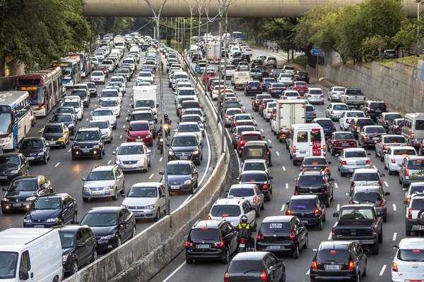

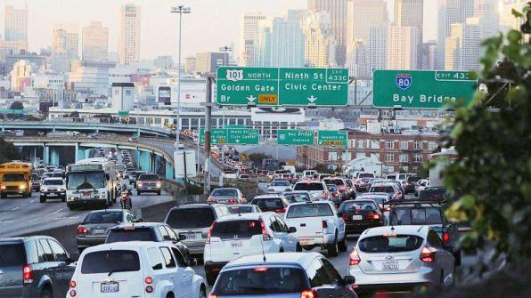

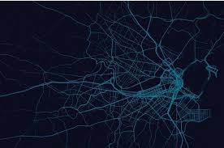

**References**

[1] “Lawrence & Associates.” *Lawrence & Associates*, www.lawrencelaws.com/.

[2] https://economics.mit.edu/files/1785

[3] *Casetext*, casetext.com/case/greenwich-taxi-inc-v-uber-techs-inc#!

[4] Borsa, Jay. “Uber Vehicle Requirements: Can You Drive for Uber with Your Car?” *Ridesharing Driver*, 21 Apr. 2018, www.ridesharingdriver.com/uber-vehicle-requirements-can-you-drive-for-uber-with-your-car/.

[5] “Learn How Uber Keeps Riders and Drivers Safe | Uber.” *Uber.com*, [www.uber.com/safety/](http://www.uber.com/safety/).

[6] “Tipping Point.” *The Economist*, The Economist Newspaper, 20 Apr. 2009, www.economist.com/node/13522500.

[7] Koch, Richard. “How Uber Used a Simplified Business Model to Disrupt the Taxi Industry.” Entrepreneur, Entrepreneur, 3 Jan. 2017, [www.entrepreneur.com/article/286683](http://www.entrepreneur.com/article/286683).

*[8]* “How Do Car Ownership Costs Compare to Using Uber?” Pennsylvania, 31 May 2015, newsroom.uber.com/economics-of-car-ownership/.

*[9]* Wallsten, Scott. “Has Uber Forced Taxi Drivers to Step Up Their Game?” The Atlantic, Atlantic Media Company, 9 July 2015, [www.theatlantic.com/business/archive/2015/07/uber-taxi-drivers-complaints-chicago-newyork/397931/](http://www.theatlantic.com/business/archive/2015/07/uber-taxi-drivers-complaints-chicago-newyork/397931/).

*[10]* Kupperman, Jake. “Is Ride-Sharing a Winner-Takes-All Market? – Jake Kupperman – Medium.” Medium, Augmenting Humanity, 14 Feb. 2018, medium.com/@jbkupperman/is-ride-sharing-a-winner-takes-all-market-3d0a3b7f113f.

*[11]* Fox, Justin. “It Will Take a Lot to Kill Uber.” Bloomberg.com, Bloomberg, 2 Aug. 2017, www.bloomberg.com/view/articles/2017-08-02/it-will-take-a-lot-to-kill-uber.

*[12]* Bliss, Laura, and CityLab. “An Extra $7 Billion For Uber? Yeah, We'd Totally Pay It.” CityLab, 15 Sept. 2016, www.citylab.com/transportation/2016/09/uber-consumer-surplus/500135/.

*[13]* Schwartz, Elaine. “Uber's Surge Pricing Displays Classic Supply and Demand.” Econlife, 22 Jan. 2017, econlife.com/2017/01/ubers-surge-pricing/.

[14] Zimmerman, Whitney. “The Network Effects of Uber's Master Plan, and Why Travis Kalanick Is Captain Nemo.” Hacker Noon, Hacker Noon, 16 Sept. 2016, hackernoon.com/the-network-effects-of-ubers-master-plan-or-why-travis-kalanick-is-captain-nemo-46d521a03b2d.

[15] Kim, Larry. “23 Crazy Facts About Uber, the $51 Billion Startup Success.” Inc.com, Inc., 17 Sept. 2015, www.inc.com/larry-kim/23-crazy-facts-about-uber-the-51-billion-startup-success.html.

[16] “India Railways Is Using AI-Driven Surveillance Cameras to Monitor Its Kitchens.” Business Insider, Business Insider India, [www.businessinsider.in/](http://www.businessinsider.in/).

[17] Bogage, Jacob. “How Much Uber Drivers Actually Make per Hour.” The Washington Post, WP Company, 27 June 2016, www.washingtonpost.com/news/the-switch/wp/2016/06/27/how-much-uber-drivers-actually-make-per-hour/?noredirect=on&utm_term=.5226ccff771a.

[18] Singer-Vine, Jeremy, and Caroline O’Donovan. “Methodology For Estimating Uber Drivers' Hourly Net Earnings.” BuzzFeed, BuzzFeed, www.buzzfeed.com/jsvine/methodology-for-estimating-uber-drivers-hourly-net-earnings?utm_term=.tpaYj9dKE#.pa3bY6yV1.

[19] “What Is Dynamic Pricing?” Uber, help.uber.com/h/34212e8b-d69a-4d8a-a923-095d3075b487.

[20] “Uber Segmentation, Targeting and Positioning.” Research-Methodology, 25 Mar. 2018, research-methodology.net/uber-segmentation-targeting-and-positioning/.

[21] Jurdak, Raja, et al. “Who's to Blame When Driverless Cars Have an Accident?” The Conversation, The Conversation, 6 May 2018, theconversation.com/whos-to-blame-when-driverless-cars-have-an-accident-93132.

[22] “Vehicles, Air Pollution, and Human Health.” Union of Concerned Scientists, w[ww.ucsusa.org/clean-v](http://ww.ucsusa.org/clean-v)ehicles/vehicles-air-pollution-and-human-health#.WvIptpch2Uk.

[23] Galbraith, Kate. “Are Uber and Lyft Helping or Hurting the Environment?” The Guardian, Guardian News and Media, 21 Jan. 2016, [www.theguardian.com/environment/2016/jan/21/uber-lyft-helping-hurting-environment-climate-change](http://www.theguardian.com/environment/2016/jan/21/uber-lyft-helping-hurting-environment-climate-change).

[24] *Ahmadali's Blog*, www.ahmadalia.com/blog/2011/01/the-essence-of-groupon.html.